15.30: Let the wave traveling in the The wave traveling in the direction is inverted due to reflection from the fixed end of the string at The wave function of the resulting standing wave is then 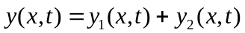, where

